Team SE7EN

Team Member

Hiang Guov

Chengen Li (Taylor)

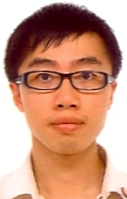

Good at designing class structure, algorithm and code implementation, writing class design documents

Nur Shamiza Amira Murat (Miza)

Erqian Zhang(Hans)

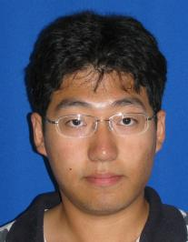

Love coding and software design, also would like to do testing and user interface development

Haowei Zheng(Wilson)

Contact Information

|  |  |  |  |  |
| --- | --- | --- | --- | --- |
|  | ID | UPI | email | Phone No. |
| Hiang | 1509124 | hguo031 | hguo031@aucklanduni.ac.nz | 02102730074 |
| Taylor | 5999263 | cli207 | cli207@aucklanduni.ac.nz | 0211641986 |
| Miza | 5915162 | nmur822 | nmur822@aucklanduni.ac.nz | 0220722469 |
| Hans | 4960981 | ezha006 | ezha006@aucklanduni.ac.nz | 02102235009 |
| Wilson | 1829574 | hzhe024 | hzhe024@aucklanduni.ac.nz | 0212606520 |

Team Meeting Schedule (approximately 8 hours a week)

Monday 13:00 – 14:00

Wednesday 13:00 – 14:00

Friday 12:00 – 13:00

Saturday 13:00 – 18: 00 (Group Coding)

Team Manager Roster

|  |  |  |
| --- | --- | --- |
|  | Team Manager | Deputy Manager |
| Week 7 | Hiang | Taylor |
| Week 8 | Taylor | Miza |
| Week 9 | Miza | Hans |
| Week 10 | Hans | Wilson |
| Week 11 | Wilson | Hiang |
| Week 12 | Hiang | Hans |